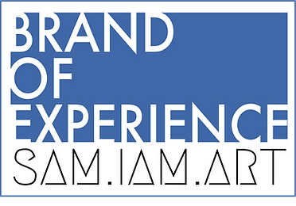
FOR IMMEDIATE RELEASE
June 1, 2022

Website: brandofexperience.com
Contact: Samuel Arencibia
Phone: 347-480-3747
Email: info@brandofexperience.com

Samuel Arencibia is proud to present Brand of Experience. An art brand that can empower creators to push the boundaries of audience-based experiences
New York, NY: Brand of Experience’s mission is to create boundary-pushing narrative experiences putting the audience in the center of the story. Committed to producing sustainable art and respecting its artists. Delivering both at-home and in-person experiences it takes you on an immersive, exciting journey for the whole family, creating lasting memories and characters.
​
Founded by Samuel Arencibia, with Communication Direction by Emilia Smart-Denson, and content creation by Next Stop Creatives, plus a powerhouse team of independent artists working on each experience Brand of Experience is proud to be a collective of artists.

Brand of Experience will launch its first experience later this month with The Grid Hack: an outdoor experience that is a one-of-a-kind audio play meets outdoor adventure. Later this year, Brand of Experience will present it’s first box experience. An interactive story adventure delivered right to your home.

To learn more, visit brandofexperience.com

Logos & Photos

